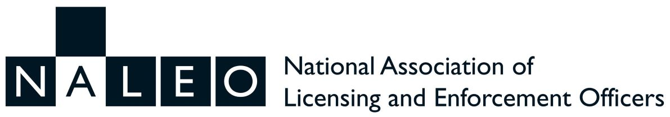
THE BRYAN DENBY AWARD 2021-22 NOMINATION FORM

Eligibility Criteria for the Award:

“Any person who has made a significant contribution to Licensing, either locally or nationally is eligible.” Reasons MUST be given for the nomination and the Nominee MUST have given their consent to the nomination prior to submission.

ALL NOMINATIONS MUST BE GIVEN BY THE NALEO MEMBER PROPOSER, COMPLETE WITH THE REASONS FOR THE NOMINATION.

To make a nomination, please complete the following:
Proposer’s Name and Contact details

Name of Nominee
Reasons for the nomination (continue on additional sheet(s) if necessary)
I, the above named NALEO member, hereby propose that the Committee consider awarding the 2019-20 Bryan Denby Award for services to Licensing to my nominee as named above. I confirm that the nominee and has consented to their nomination
Signed |  |  | Date:

Nominations must reach the Chair of NALEO by 16th March 2022. nationalchair@naleo.org.uk

The decision of the Panel will be final. It is expected that the Recipient of the Award will be announced at the AGM on 6th April 2022.

