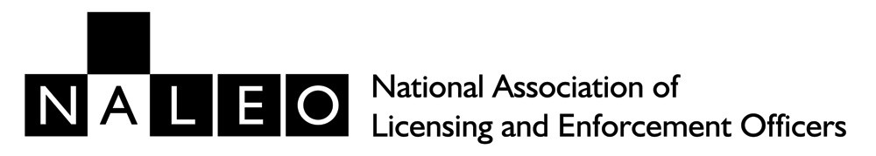
Annual General Meeting
Monday 21st October 2024 @ 10.30am
Teams Meeting - Online
(MEMBER PARTICIPATION ONLY)

- Chairman's Opening Address
- Apologies for absence
- Minutes of the Meeting held online on 6th April 2022
- Correspondence
- Business specially brought forward by direction of the Chair
- Election of scrutineers
- Election of the Committee
- Notices of Motion
Motion:
Following an invitation from the Institute of Licensing to consider merging with the National Association of Licensing and Enforcement Officers, that the association agrees to the merger subject to the proposed conditions outlined in the invitation. and that the National Committee take the appropriate steps to expedite the proposed merger.
Proposed: John Miley National Chair
Seconded: Teresa Bowley National Secretary

- Financial Report
- Declaration of result of Ballot
- Determination of Annual Subscriptions
- Election of Auditors
- Any other Business brought forward by permission of the Meeting.
- Close of AGM

